- Problem: Signal Convolution using Unit Impulse Signal

Logical Solution:
- x(n)=…….a₁δ(n+2)+a₂δ(n+1)+a₃δ(n)+a₄δ(n-1)+a₅δ(n-2)+………….
- The output of LTI system of impulse signal is h(n).
- y(n)= …….a₁h(n+2)+a₂h(n+1)+a₃h(n)+a₄h(n-1)+a₅h(n-2)+………….

Source Code:
import numpy as np
import matplotlib.pyplot as plt

x_n=np.array([2,0,2])
x_t=0
h_n=[1,1,1]
h_t=1
length=len(x_n)+len(h_n)-1
for i in range(length-len(h_n)+1):
h_n.append(0)
h_n=np.array(h_n)
print(length,h_n)


Output-h(n)
# i) 2del(n)
t=np.array([ i-x_t for i in range(len(x_n))])
del_n=np.array([0 for i in range(len(x_n))])
del_t=x_t
for i in t:
if i==0:
del_n[i+x_t]=x_n[i]
else:
del_n[i]=0
del_n=np.array(del_n)
plt.grid(True)
plt.stem(t,del_n)
plt.show()

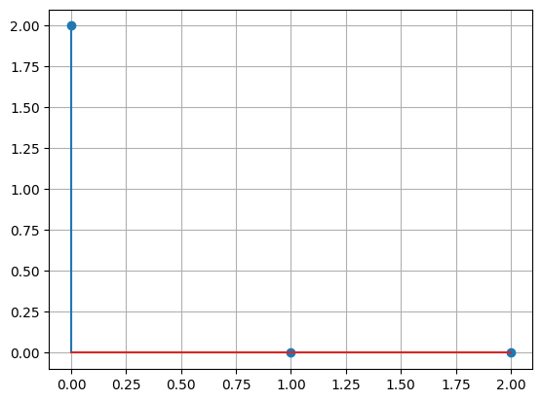
Figure-2δ(n)

# ii) 2h(n)
h1=h_n*del_n[0]
t=np.array([ i-h_t for i in range(len(h_n))])
plt.grid(True)
plt.stem(t,h1)
plt.show()

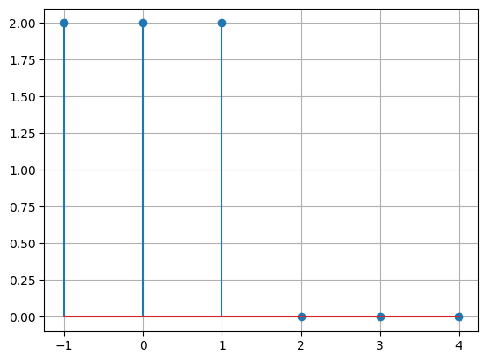
Figure-2h(n)
# iii) 2del(n-2)

t=np.array([ i-x_t for i in range(len(x_n))])
del_n=np.array([0 for i in range(len(x_n))])
print(del_n)
del_t=x_t
for i in t:
if i==2:
del_n[i+x_t]=x_n[i]
else:
del_n[i]=0
print(del_n)
del_n=np.array(del_n)
print(del_n,t)
plt.grid(True)
plt.stem(t,del_n)
plt.show()

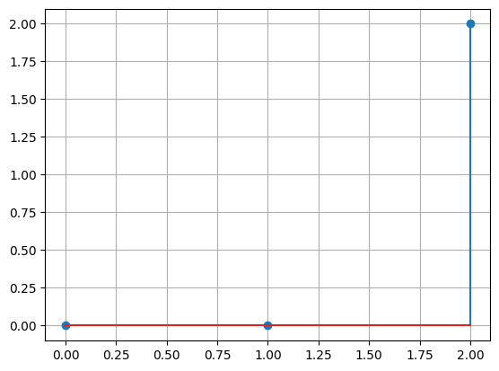
Figure-2δ(n-2)

# iv) 2h(n-2)
for i in range(2):
h_n=h_n[:-1]
h_n=np.insert(h_n,0,0)
h2=h_n*del_n[2]
print(h2)
t=np.array([ i-h_t for i in range(len(h_n))])
plt.grid(True)
plt.grid(True)
plt.stem(t,h2)
plt.show()

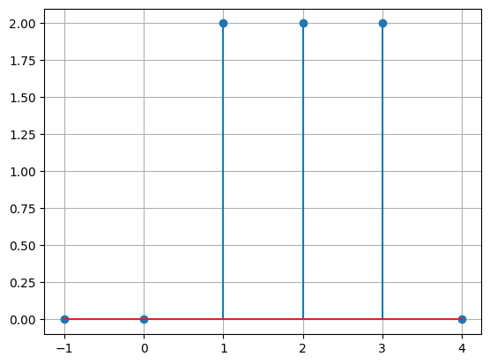
Figure-2h(n-2)

# v) h(n)+h(n-2)
y_n=h1+h2
print(y_n)
t=np.array([ i-h_t for i in range(len(h_n))])
plt.grid(True)
plt.stem(t,y_n)
plt.show()

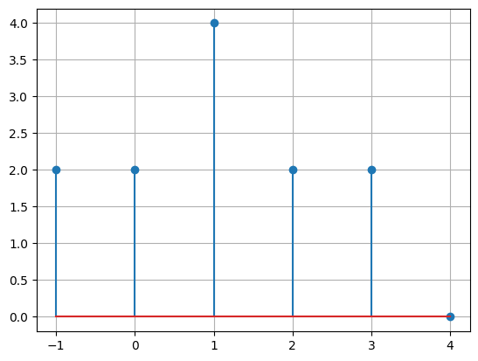
Figure-2h(n)+2h(n-2)

Discussion:
- Firstly, determine each unit impulse signal from the original signal
- Then send the impulse signal to the LTI system to get h(n), response signal

- Problem: Signal Convolution using Summation Formula

Logical Solution:
- y(n)=$\sum_{k=-∞}^{∞}{x\left(n\right)*h(n-k)}$

Source Code:
import numpy as np
import matplotlib.pyplot as plt

x_n=np.array([1,2,3])
# x_n=np.array([1,2,4,8])
lenx=len(x_n)
x_t=0
h_n=np.array([4,5,6])
h_t=1
y_t=h_t
length=len(x_n)+len(h_n)-1
h_n=h_n[::-1]

for i in range(len(h_n)):
x_n=np.insert(x_n,0,0)

for i in range(len(h_n)):
x_n=np.append(x_n,0)

l=length-len(h_n)-h_t+1
for i in range(l):
h_n=np.append(h_n,0)
h_t-=1

for i in range(len(x_n)-len(h_n)):
h_n=np.append(h_n,0)

print(h_n,x_n,h_t)


Output- h(n), x(n), h(t)
mn=min(h_t,x_t)
t=[]
y_n=[]
for i in range(mn,length+2):
y_n.append(0)
t.append(i-1)
for j in range(len(h_n)):
y_n[-1]+=x_n[j]*h_n[j]

h_n=h_n[:-1]
h_n=np.insert(h_n,0,0)
h_t+=1
plt.stem(t,y_n)
plt.grid(True)
plt.show()

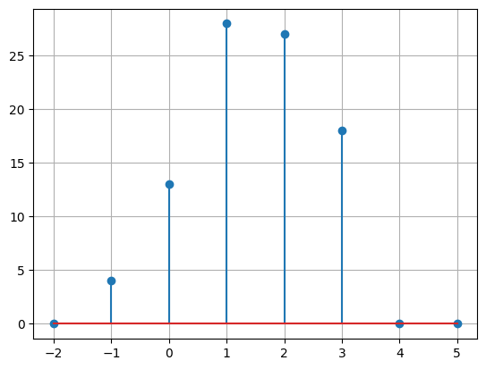
Output- Convoluted Signal

Discussion:
- Firstly, I have reversed the response signal.
- Secondly, left shift that signal for proper calculation.
- Then shift that signal and multiply the values and sum it.

- Problem: Convolution Using Built-in Function (0/1 Signal)

Logical Solution:
- y(n)=$\sum_{k=-∞}^{∞}{x\left(n\right)*h(n-k)}$

Source Code:
import numpy as np
import matplotlib.pyplot as plt

x_n=[1,1,1,1,1,0,0,0,0,0,1,1,1,1,1,0,0,0,0,0]
h_n=[.2,.2,.2,.2,.2]

plt.stem(x_n)
plt.show()

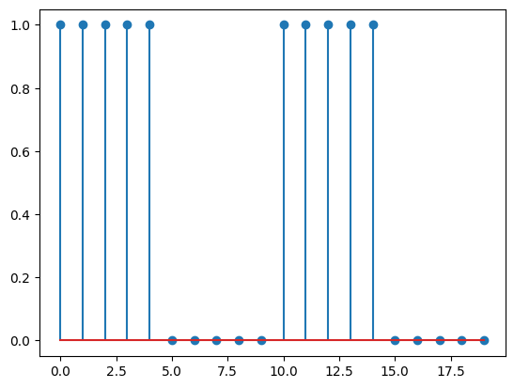
Fig- 0/1 Signal

y_n=np.convolve(x_n,h_n)
plt.stem(y_n)
plt.show()

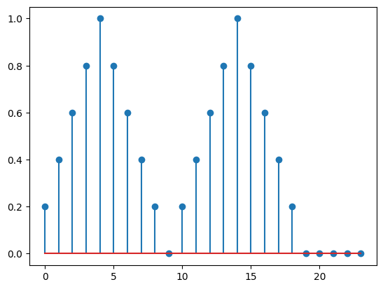
Output- Convoluted Signal

Discussion:
- Here I have used built-in numpy function which is numpy.convolve(x,h).

- Problem: Convolution Using Built-in Function (Sine Signal)

Logical Solution:
- y(n)=$\sum_{k=-∞}^{∞}{x\left(n\right)*h(n-k)}$

Source Code:
import numpy as np
import matplotlib.pyplot as plt

n=np.linspace(-1,1,1000)
x_n=np.sin(2*np.pi*n)
plt.plot(x_n)
plt.show()

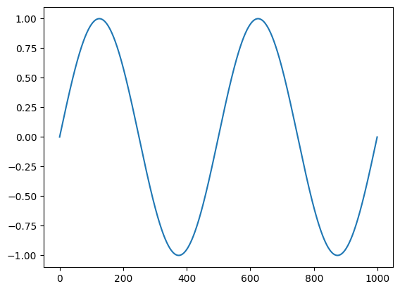
Fig- Sine Signal

noise=np.random.rand(len(n))
noisy=x_n+noise
plt.plot(noisy)
plt.show()
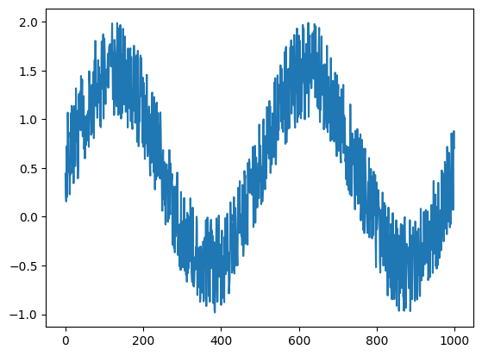
Output- Noisy Sine Signal
filtered=np.ones(100)/100
after_filter=np.convolve(noisy,filtered)
plt.plot(after_filter)
plt.show()
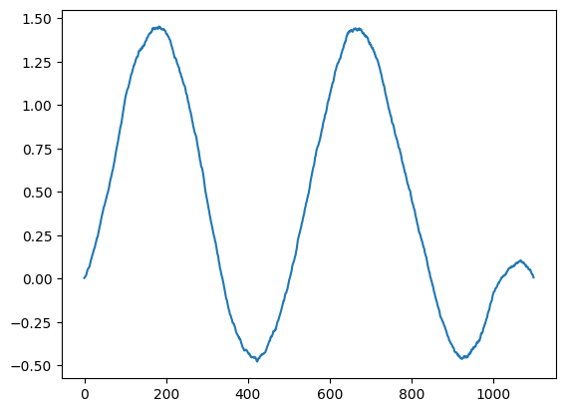
Fig- Filtered Signal

Discussion:
- After adding noise to original sinusoidal signal, pass it with the filtered value to the numpy built in function for convolution.

